[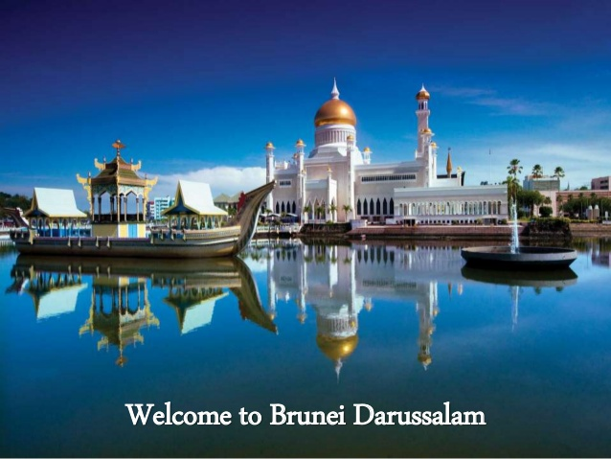](https://www.google.com/url?sa=i&rct=j&q=&esrc=s&source=images&cd=&cad=rja&uact=8&ved=2ahUKEwj-5Yrd-KfdAhUN448KHUdQBOUQjRx6BAgBEAU&url=https%3A%2F%2Fwww.slideshare.net%2FPakpoomKapitta%2Fbrunei-59311134&psig=AOvVaw1qhuEVEUHdd__o8RFNVuGl&ust=1536377011630997)